IKEAS Chocolate Sofa

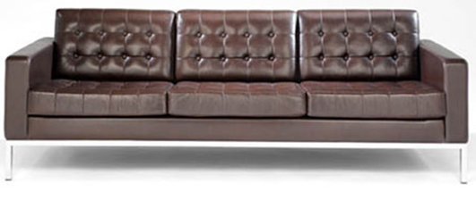

|  |
| --- |
| **DESCRIPTION** |
| Chocolate Sofa produced by IKEA Company, presents a hand stitched very comfortable adjustable sofa. The long legs help to clean inside the sofa and reach to the places where many sofas because of their low height prevented to reach. The legs of the sofa are made from titanium steel which is the strongest metal and unbreakable. The form filled thick leather adds comfort and class to the sofa which is easily adjusted in any room of the house. |

|  |  |  |
| --- | --- | --- |
| **Price** | **1600$** | |
| **Dimensions** | **H** x **W** x **L** | **34in x 31in x 57in** |
| **Features** | **It is build for three people but because of titanium legs it can hold weights of five people.** | |
| **Finished** | **Smooth Hand Stitched Leather** | |
| **Available in** | **Brown and Black** | |